Key Logger
Project Report

Mini Project (ICS751) Degree
BACHELOR OF TECHNOLOGY (CTIS)

PROJECT GUIDE:  Dr. Sunkulp Goel | SUBMITTED BY:  Akshat Sharma (TCA2150001) Prashant Chauhan (TCA2150003)

August - December, 2024


FACULTY OF ENGINEERING & COMPUTING SCIENCES TEERTHANKER MAHAVEER UNIVERSITY, MORADABAD

ACKNOWLEDGEMENT

I am deeply grateful to the Faculty of Engineering & Computing Sciences, Teerthanker Mahaveer University, for providing me with the opportunity to work on this project, "KeystrokeKey Logger." This project has been an invaluable learning experience, blending theoretical knowledge with practical implementation.
I sincerely thank my project guides, both internal and external, for their unwavering support, encouragement, and expertise. Their guidance has been instrumental in shaping this project and ensuring its successful completion.
I extend my heartfelt thanks to my peers for their constant motivation and collaborative feedback throughout this journey. I would also like to express my gratitude to the university's library and IT labs for providing access to the necessary resources and infrastructure.
Finally, I owe my deepest gratitude to my family and friends for their encouragement and patience during this period. Their belief in my abilities provided me with the strength to overcome challenges and stay focused on my goals.
This report is a testament to the collective efforts of all those who have contributed directly or indirectly to the successful completion of this project.

Akshat Sharma Prashant Chauhan

Place: Moradabad
Date: 31/12/2024

DECLARATION

We hereby declare that this Project Report titled “Key Logger” submitted by us and approved by our project guide, the College of Computing Sciences and Information Technology (CCSIT), Teerthanker Mahaveer University, Moradabad, is a bonafide work undertaken by us and it is not submitted to any other University or Institution for the award of any degree diploma / certificate or published any time before.

Project Group : | Project Group Name/Id
Student Name: | Akshat Sharma | Signature
Student Name: | Prashant Chauhan | Signature
Project Guide: (External) | Name | Signature
Project Guide: (Internal) | Dr. Sunkulp Goel | Signature

Table of Contents
- PROJECT TITLE 5
- PROBLEM STATEMENT 5
- PROJECT DESCRIPTION 5
  - Scope of the Work 5
  - Project Modules 6
  - Context Diagram (High Level) 6
- IMPLEMENTATION METHODOLOGY 6
- TECHNOLOGIES TO BE USED 7
  - Software Platform 7
  - Hardware Platform 8
  - Tools, if any 8
- ADVANTAGES OF THIS PROJECT 9
- ASSUMPTIONS, IF ANY 10
- FUTURE SCOPE AND FURTHER ENHANCEMENT OF THE PROJECT 10
- PROJECT REPOSITORY LOCATION 12
- DEFINITIONS, ACRONYMS, AND ABBREVIATIONS 12
- CONCLUSION 12
- REFERENCES 14
Appendix
A: Data Flow Diagram (DFD)
B: Entity Relationship Diagram (ERD) C: Use Case Diagram (UCD)
D: Data Dictionary (DD) E: Screen Shots

Project Title

“Key Logger”
"Intelligent Keystroke Monitoring System: A Python-Based Solution for Capturing and Analysing Keyboard Events"
This title highlights the project’s focus on both capturing keyboard inputs and its potential for intelligent analysis, emphasizing the use of Python as the core technology. Let me know if you'd like more emphasis on specific functionalities or applications!

Problem Statement
In today's digital landscape, keystroke logging has applications ranging from usability testing to ethical system monitoring. However, creating a lightweight, efficient, and modular keystroke logger presents challenges in balancing functionality, simplicity, and security. This project addresses the need for a Python-based solution to monitor and log keyboard events in real- time while ensuring usability and flexibility for various scenarios, such as debugging and user behavior analysis.

Project Description
The project focuses on designing and implementing a Python-based keystroke logger to monitor and capture keyboard events. It uses the pynput library to detect key presses/releases and stores this data in a structured format for analysis. The project adheres to ethical standards, ensuring the logging process is clear, transparent, and compliant with legal frameworks.

Scope of the Work

In-Scope:
    - Real-time monitoring of keyboard inputs (alphanumeric and special keys).
    - Storing logged data in a human-readable text file (log.txt).
    - Displaying the captured keys in the console for immediate feedback.

Out-of-Scope:
    - Network-based monitoring or remote keylogging.
    - Encryption or advanced data protection for stored files.
    - Detection of malicious activities or intent.

Project Modules

Key Listener Module
    - Detects key presses and releases using the pynput library.
    - Differentiates between alphanumeric and special keys.

File Writer Module
    - Writes captured keyboard events to log.txt.
    - Ensures data is formatted for readability (e.g., replacing special character representations with descriptive labels).

Output Display Module
    - Prints captured key events to the console in real-time.
    - Categorizes keys as "special" or "alphanumeric" for better clarity.

Context Diagram (High Level) Inputs:
    - Keyboard key events (key press and key release).

Processes:
    - Capturing key events.
    - Categorizing keys as alphanumeric or special.
    - Logging the captured data to a file and displaying it on the console.

Outputs:
    - A text file (log.txt) containing the logged keys.
    - Console output showcasing real-time monitoring of keystrokes.

Implementation Methodology
The project is developed using Python, following a structured approach to ensure modularity and ease of testing:

Setup and Initialization:
  - Import required libraries (pynput) and define global variables.

Event Capture:
  - Implement functions to handle key presses and releases.

  - Use error handling to account for undefined or unexpected key events.

Data Storage:
  - Design a file-writing mechanism to log keys in log.txt.
  - Replace raw key representations with human-readable formats.

Real-Time Feedback:
  - Print key events to the console as they occur, differentiating between key types.

Testing and Debugging:
  - Perform unit testing on each module to ensure reliability.
  - Maintain a defect log to document and resolve bugs efficiently.

Documentation:
  - Include a user manual explaining the software's operation and ethical considerations.

Supporting Diagrams
- Data Flow Diagram (DFD): Illustrates how data flows from the input (keyboard events) to storage and output.
- Entity-Relationship Diagram (ERD): Shows the relationship between key events and log entries.
- Use Case Diagram: Depicts user interaction with the logger system.
- Flowchart: Visualizes the sequential steps of the logging process.

Technologies to be used
This section outlines the technologies, tools, and hardware configurations used in the project to ensure successful development, testing, and deployment of the keystroke logger.

Software Platform

Front-end:

  - Description: As the project is a console-based application, it does not include a graphical user interface. Instead, the output is displayed directly on the terminal or console, making it lightweight and simple to use.

Back-end:
  - Programming Language: Python 3.9+
    - Reason: Python’s extensive libraries, ease of syntax, and compatibility with modern operating systems make it an ideal choice for event-driven projects.

Libraries:

pynput:
      - Purpose: To monitor and control keyboard events.
      - Version: 1.7.6 or later.
    - os (optional): To manage file-related operations if additional extensions are required.

Hardware Platform
The following hardware specifications are recommended for running and testing the application:
    - Processor: Intel Core i3 or equivalent (minimum); Core i5 or higher recommended.
    - RAM: Minimum 4 GB; 8 GB or higher recommended for multitasking during testing.

Hard Disk:
      - Minimum free space of 500 MB for Python installation and log file storage.
      - SSD preferred for faster file operations.

Operating System:
      - Compatible with Windows (10 or later), Linux (Ubuntu 20.04 or later), or macOS (10.15 or later).

Editor:
      - Visual Studio Code (Microsoft, Version 1.70+).
      - Alternative: PyCharm Community Edition (JetBrains, Version 2021.3 or later).

Browser:
      - Any modern browser (Google Chrome, Mozilla Firefox, or Microsoft Edge) if additional resources or documentation access is required.

Tools, if any

Tools Used During the Project Life Cycle:

Development:

Visual Studio Code:

    - Vendor: Microsoft
    - Version: 1.70 or later.
    - Purpose: Provides an efficient and feature-rich environment for Python development.

Testing:

Python Debugger (pdb):
    - Purpose: Used for step-by-step debugging of the application to identify and resolve issues in the codebase.

Documentation:

Microsoft Word:
    - Vendor: Microsoft
    - Version: 2016 or later.
    - Purpose: To document the project's progress, reports, and findings.
- Version Control (Optional):
  - Git:
    - Vendor: Open-source.
    - Version: 2.30 or later.
    - Purpose: To manage changes in the code during development phases.
These tools and platforms ensure a smooth development process, optimal resource utilization, and high efficiency in implementing the keystroke logger project.

Advantages of this Project
The keystroke logger project offers several benefits, making it valuable for both academic and practical purposes:
- Lightweight and Efficient:
  - The application is resource-friendly, requiring minimal processing power and memory, making it suitable for deployment on low-spec systems.
- Educational Value:
  - Demonstrates real-world applications of Python libraries such as pynput and event- driven programming concepts.

  - Helps students understand hardware-software interaction, particularly with input devices like keyboards.
- Real-Time Monitoring:
  - Captures and displays keyboard events in real-time, making it useful for debugging and user behavior analysis.
- Ease of Implementation:
  - Written in Python, the project is simple to understand, modify, and extend, even for beginners in programming.
- Adaptability:
  - Can be tailored for various use cases such as usability testing, basic analytics, or ethical monitoring in controlled environments.
- Cross-Platform Compatibility:
  - Works seamlessly across major operating systems (Windows, macOS, Linux) due to
Python’s portability.
- Transparency:
  - Logs are stored in human-readable formats, making it easy to review and analyze the captured data.

Assumptions, if any
"NONE”

Future Scope and further enhancement of the Project
This project lays the groundwork for more sophisticated keystroke monitoring systems. Several enhancements and expansions can be implemented to improve its functionality and usability:

Security Features:
  - Encryption: Secure the log files with encryption to prevent unauthorized access.
  - Access Controls: Introduce user authentication to control access to the logger.

Advanced Analytics:
  - Integrate with data analysis tools to extract insights such as typing speed or frequently used keys.
  - Enable visualization of data through charts and graphs.

GUI Development:

  - Create a user-friendly graphical interface for better interaction and easier control of logging features.

Network-Based Logging:
  - Expand to log keyboard events over a network, enabling centralized monitoring. This is useful for IT administrators in organizational settings.

Multi-Language Support:
  - Enhance the application to support non-English keyboards and special character sets.

Integration with Machine Learning:
  - Apply machine learning models to detect anomalies in typing patterns, which could be used for biometric authentication or fraud detection.

Cloud Integration:
  - Store logs securely in the cloud for remote access and backup.

Mobile Device Compatibility:
  - Extend the project to work on mobile platforms, capturing touch events or keystrokes from external keyboards.

Automated Alerts:
  - Set up alerts for specific key combinations or activity patterns, enhancing usability in monitoring scenarios.

Compliance Monitoring:
  - Add features for regulatory compliance by anonymizing sensitive data and tracking usage logs for auditing.
By implementing these enhancements, the project can evolve into a comprehensive monitoring and analytics tool suitable for a wide range of applications.

Project Repository Location

S# | Project Artifacts (softcopy) | Location  (Mention Lab-ID, Server ID, Folder Name etc.) | Verified by Project Guide | Verified by Lab In-Charge
1. | Project Synopsis Report (Final Version) |  | Name and Signature | Name and Signature
2. | Project Progress updates |  | Name and Signature | Name and Signature
3. | Project Requirement specifications |  | Name and Signature | Name and Signature
4. | Project Report (Final Version) |  | Name and Signature | Name and Signature
5. | Test Repository |  | Name and Signature | Name and Signature
6. | Any other document, give details |  | Name and Signature | Name and Signature

Definitions, Acronyms, and Abbreviations

Abbreviation | Description
KEY_EVT | Key Event: Represents individual keyboard interactions (key press or release).
LOG_FILE | Log File: A file where captured keystrokes are recorded for analysis and reference.
TEMP_MEM | Temporary Memory: A volatile storage area used for holding keystroke data temporarily.
Pynput | A Python library for monitoring and controlling input devices like keyboards and mice.
ERD | Entity-Relationship Diagram: A graphical representation of entities and their relationships in the system.
DFD | Data Flow Diagram: A diagram showing the flow of data within the system, including inputs, processes, and outputs.
SRS | Software Requirements Specification: A document detailing the project’s functional and non-functional requirements.
Timestamp | A record of the precise time when a key event occurs, used for analysis and debugging.
Keylogger | A tool or program designed to capture and record keystrokes from a keyboard.
Ethical Logging | The practice of monitoring keystrokes with user consent for legal and legitimate purposes.

Conclusion
This project, "Intelligent Keystroke Monitoring System: A Python-Based Solution for Capturing and Analysing Keyboard Events," successfully demonstrates the potential of Python in

developing lightweight and efficient solutions for real-time event monitoring. The keystroke logger encapsulates the essence of simplicity, modularity, and functionality, offering a comprehensive system for capturing and analyzing keyboard interactions.
Through this project, I explored critical concepts such as event-driven programming, file handling, and modular application design. Leveraging the pynput library, the logger efficiently captures and differentiates between alphanumeric and special keys, ensuring real-time feedback and accurate logging. This project also emphasizes ethical use, highlighting its applications in usability testing, debugging, and controlled system monitoring.
The outcomes of this project reaffirm the importance of structured development methodologies, from defining clear problem statements to designing modular and maintainable systems. The testing phase ensured that the application met its functional requirements and maintained accuracy across various scenarios.

Recommendations
Implementing features like encryption for logs, GUI-based control panels, and machine learning- based behavior analysis can significantly enhance the project’s functionality. Extending the application to support remote logging or mobile platforms would also increase its usability in various domains.

Broader Impact

The project underscores the growing importance of event-driven applications in today’s digital landscape. By adhering to ethical practices, such tools can significantly contribute to improving system security, user experience testing, and educational applications. This keystroke logger can act as a foundational step toward more complex monitoring and analytical systems, catering to diverse use cases.

1. | Project Synopsis | Akshat Sharma, Prashant Chauhan | 1 | 02-12-2024
2. | Project Requirements | Akshat Sharma, Prashant Chauhan | 1 | 02-12-2024
3. | Python Documentation | Python Software Foundation | 3.9+ | Updated Annually
4. | Pynput Library Documentation | Open Source | 1.7.6 | Accessed Online
5. | Event-Driven Programming Tutorials | GeeksforGeeks | N/A | Accessed Online
6. | File Handling in Python | Tutorialspoint | N/A | Accessed Online
7. | Ethical Keylogging Practices | TechNet Community | N/A | 2024
8. | Data Flow Diagram Guidelines | IEEE Xplore | N/A | 2024
9. | ERD and Database Design Concepts | DB-Design.org | N/A | Accessed Online
10. | TMU Academic Guidelines for Project Reports | Teerthanker Mahaveer University | 1 | Current Academic Year

References

SR.NO | Reference Details | Owner | Version | Date

Sources for Access

Python Documentation: https://docs.python.org/

pynput Documentation: https://pynput.readthedocs.io/

GeeksforGeeks Tutorials: https://www.geeksforgeeks.org/

IEEE Xplore: Available via institutional subscription or https://ieeexplore.ieee.org/.

TMU Guidelines: Available in the university's academic resource repository.

Annexure A
Data Flow Diagram (DFD)

(Mandatory)

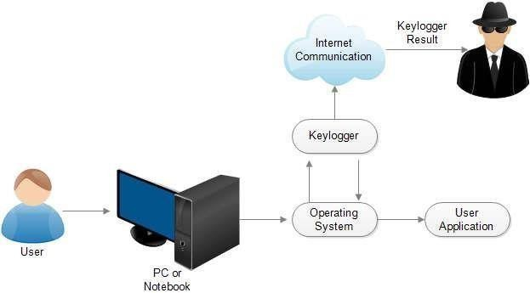

Annexure B
Entity-Relationship Diagram (ERD)

(Mandatory)

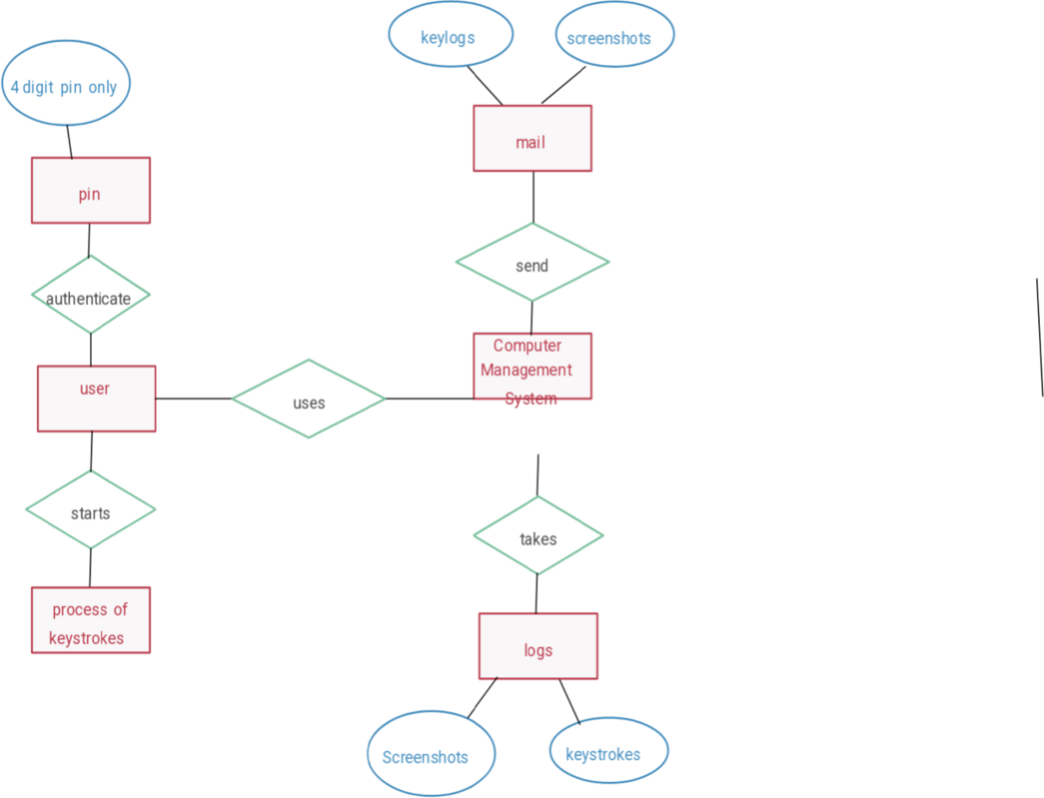

Annexure C
Use-Case Diagram (UCD)

(Optional)

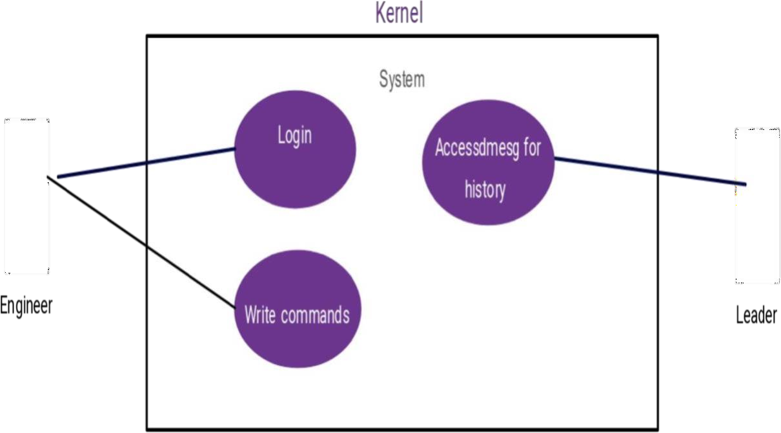

Annexure D Data Dictionary (DD)

(Mandatory)

Key Events Table (KEY_EVT)

Field | Data Type | Description
KEY-ID | Number | Unique identifier for each key event.
KEY-Type | Text | Type of key (Alphanumeric or Special).
KEY-Value | Text | The actual value of the key pressed.
KEY-Timestamp | Timestamp | Time when the key press event occurred.

Log File Table (LOG_FILE)

Field | Data Type | Description
LOG-ID | Number | Unique identifier for each log entry.
LOG-Content | Text | Concatenated string of logged keys.
LOG-Filepath | Text | Path where the log file is stored.
LOG-Timestamp | Timestamp | Time when the log file was created or updated.

Temporary Memory Table (TEMP_MEM)

Field | Data Type | Description
TEMP-ID | Number | Unique identifier for temporary entries.
TEMP-Data | Text | Captured key data held temporarily.
TEMP-Status | Text | Processing status (e.g., "pending", "logged").

Annexure E Screen Shots

Home Page: Source Code-

